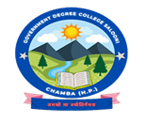
GOVERNMENT DEGREE COLLEGE SALOONI, DISTRICT CHAMBA (HP)
ANNUAL FUNCTION 2024-25

